Below are some JPEG files for you to use for business cards. You have a front side (with the Blissborn logo on it) and a back side if you would like to use it. If you are printing your own, work with the next page. You can also save the pictures below to your own computer and work from there. Just right click on the picture to see your options (I suggest saving as a JPEG file). Pro tip: make a file for yourself on your computer — call it Blissborn. Make files within it for all of your different needs: Handouts, Recordings, Marketing, etc. I would save this one into Marketing, and then Business card.

I’ve also included the guide from Vistaprint.com (which is an easy and cheap site) so you can see what the area is that you have to work with. On most sites, you can usually use your own picture and fill in your own information.

The font we used is Arial, and the other font in the logo is Times New Roman. Easy! Make sure you search the internet for coupons. Know that starting with 250 is okay…they’re cheap and easy to order, and they also often offer up a better deal when you’re in the shopping cart.
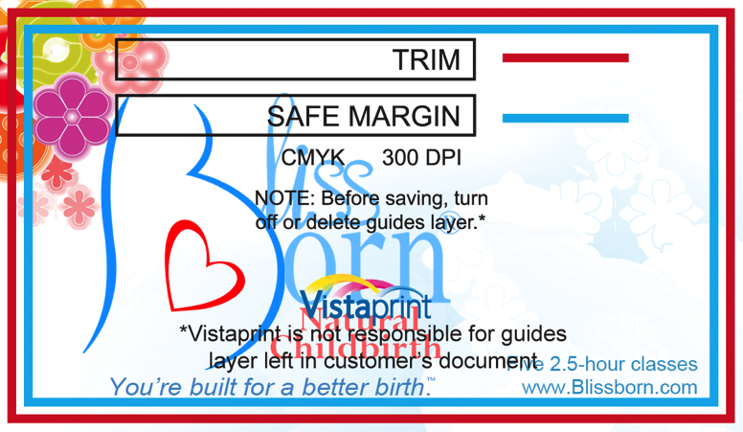

I suggest you use the following format, filled in with your own info (include your other titles and info, and your website, too):

Laura Wood, CHt, BHE
Birth Hypnosis Educator
laurawood.cht@gmail.com
(505) 699-5885

I suggest top right corner, justified to the right, in Arial 7-point font. Make sure you check it against the guides.

Let me know if us have questions! We’re here to help!

