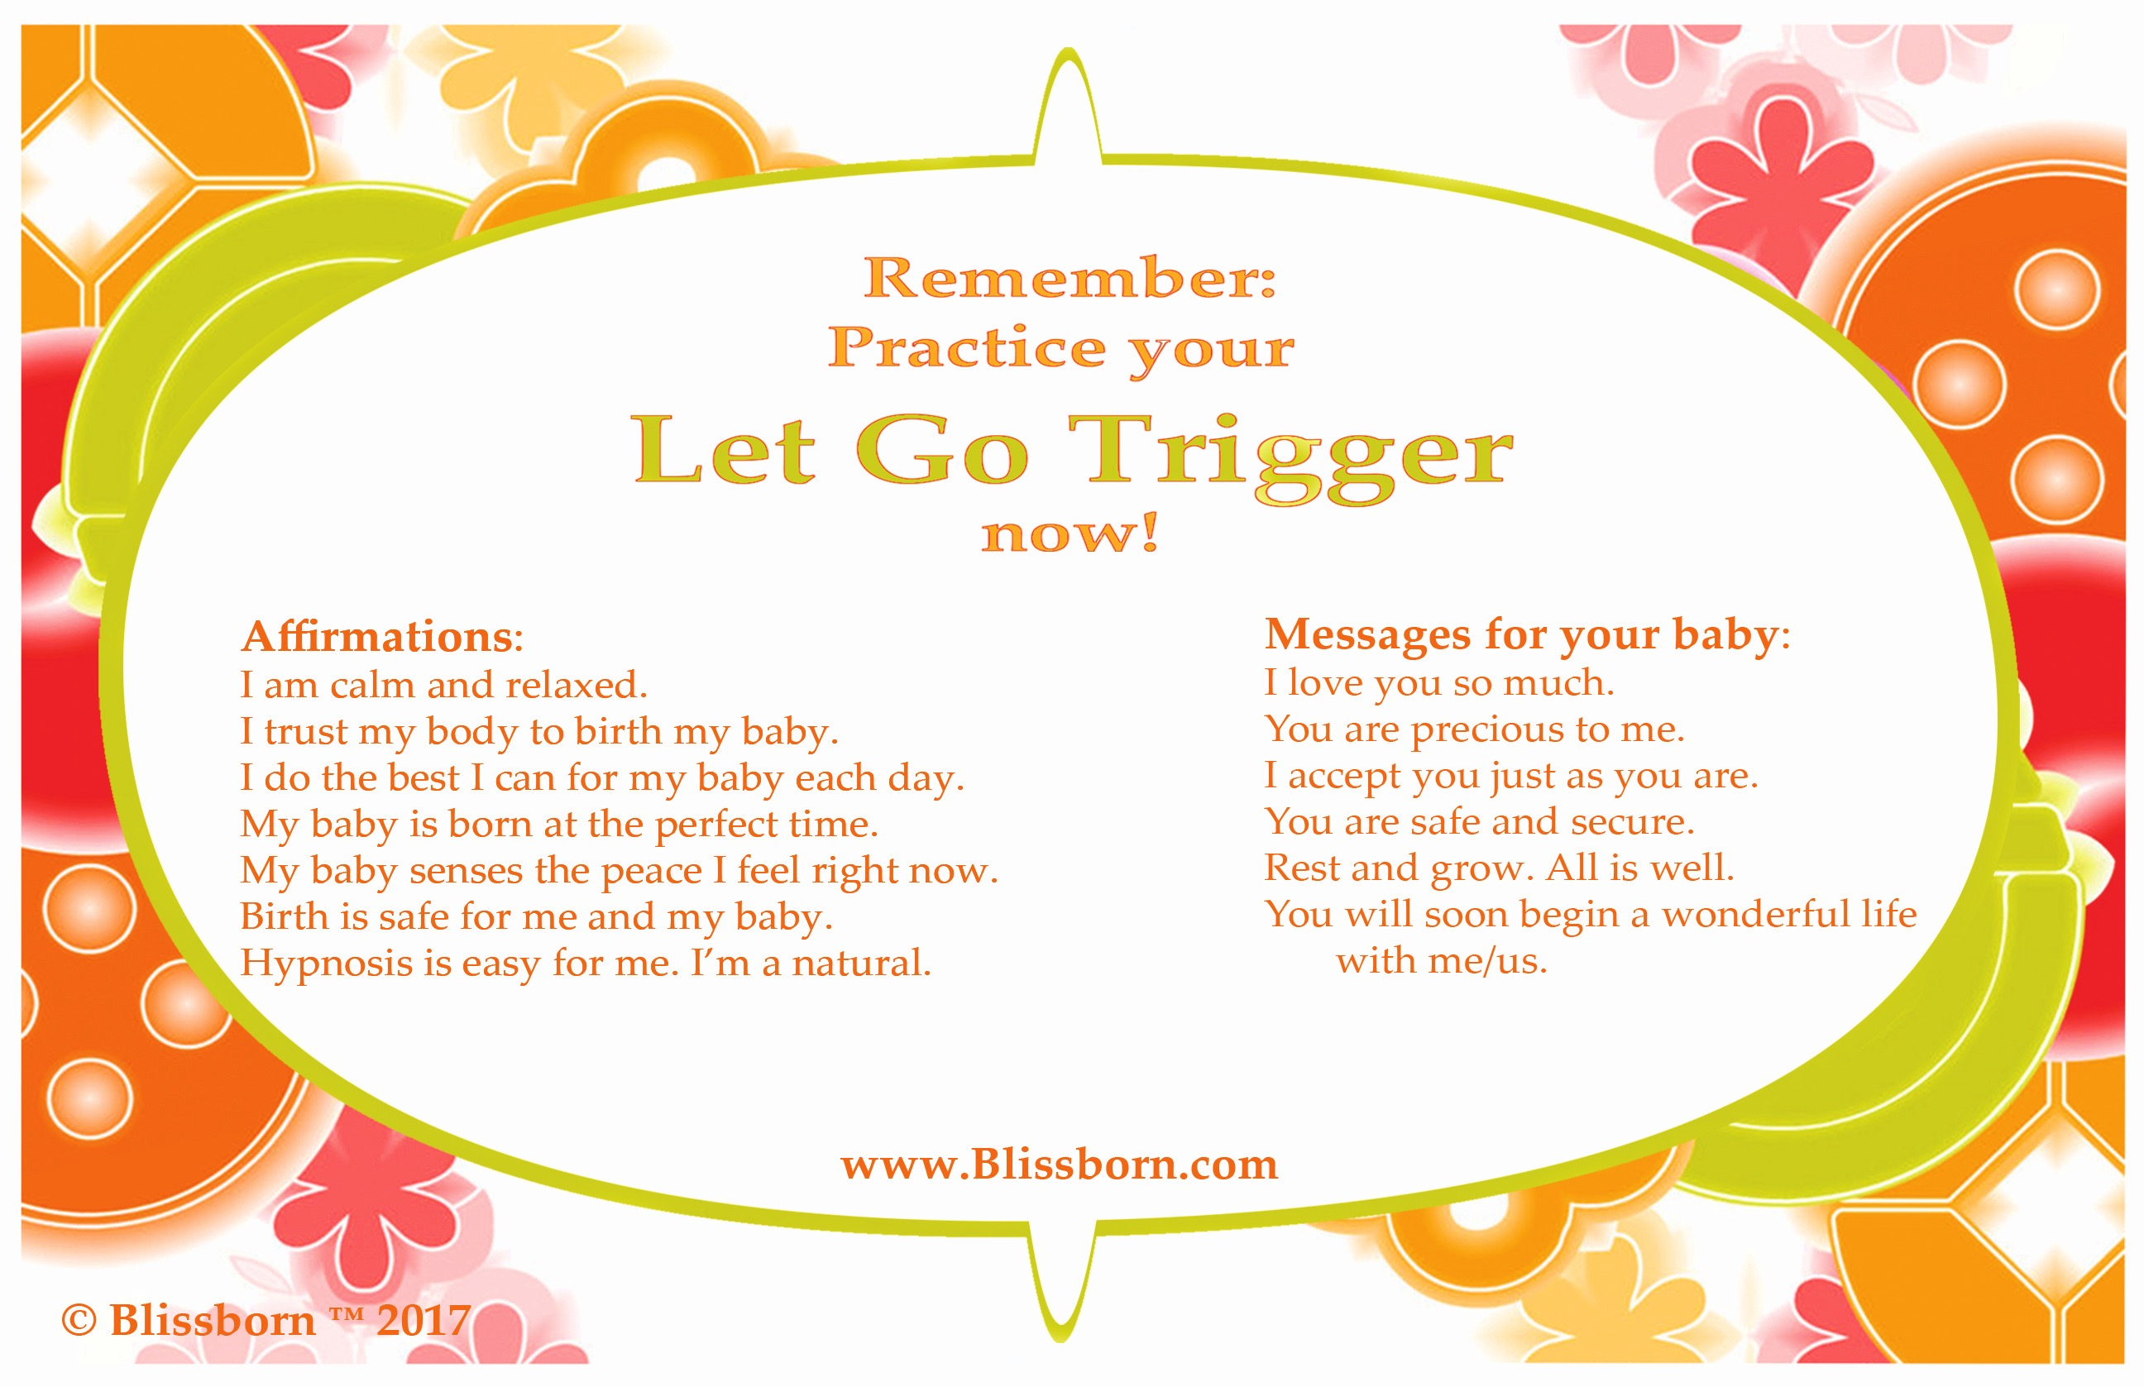
Hang the whole page or just the above picture where it will remind you each time you use the restroom. (Class 1 handout)

Daily practice with your Let Go Trigger for instant self-hypnosis

Steps:
- Set the intention of going into hypnosis for a certain period of time, or to accomplish a certain task, such as using imagery or affirmations.

- With your eyes open, take in a deep breath, and breathe out the words “Let go” slowly. As you do, let your tongue and jaw become limp and loose, and let your mouth become very moist. Close your eyes and go into a wonderful state of complete mental and physical relaxation, instantly.

- Don’t try too hard! Let it be easy. Just enjoy the relaxation. Here are some things to practice in hypnosis:

  - Imagine a wave of relaxation moving through you.
  - Repeat some affirmations. It’s OK to open your eyes to read them. Say each one three times.
  - Visualize your perfect birth, with baby head-down, facing your back.
  - Send the baby messages of love, acceptance and safety.

- Your subconscious will let you know when it's time to emerge. Set the intention of coming out of hypnosis on the count of five, and then do it, taking time to make the transition back to full awareness.

